55341

Lab 12A: Managing, monitoring, and maintaining virtual machine installations

Lab A: Implementing WSUS and deploying updates

**Scenario**

Adatum Corporation is a global engineering and manufacturing company with its head office in London, United Kingdom. An IT office and a datacenter are located in London to support the London location and other branch office locations. Adatum has recently deployed a Windows Server 2022 server and client infrastructure. Adatum has been applying updates manually to servers in a remote location. This has made it difficult to identify which servers have the updates applied and which do not. This is a potential security issue. Your task is to automate the update process by extending Adatum's WSUS deployment to include the branch office.

Objectives

After completing this lab, you will be able to:

* Implement the WSUS server role.
* Configure update settings.
* Approve and deploy an update by using WSUS.

Exercise 1: Implementing WSUS

**Scenario**

Your organization has a WSUS server called LON-SVR4, which is located in the head office. You need to install the WSUS server role on LON-SVR4 at a branch location. LON-SVR1 will use LON-SVR4 as the source for Windows Update downloads. The installation on LON-SRV4 will use the Windows Internal Database for the deployment.

The main tasks for this exercise are as follows:

1. Install the WSUS server role.
2. Configure WSUS to synchronize with an upstream WSUS server.

Task 1: Install the WSUS server role

1. Switch to [**LON-SVR1**](urn:gd:lg:a:select-vm) and send the [**CTRL+ALT+DEL**](urn:gd:lg:a:send-vm-key-combo) command and login as [**Adatum\AdatumAdmin**](urn:gd:lg:a:send-vm-keys) with the password [**Pa55w.rd**](urn:gd:lg:a:send-vm-keys).
2. If necessary, open **Server Manager**, click **Manage**, and then click **Add Roles and Features**.

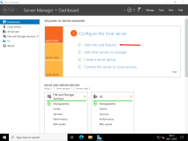

1. In the **Add Roles and Features Wizard**, click **Next**.

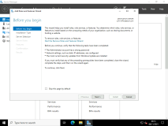

1. On the **Select installation type** page, ensure that **Role-based** or **feature-based** installation is selected, and then click **Next**.

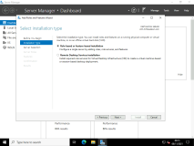

1. On the **Select destination server** page, click **Next**.

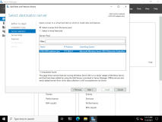

1. On the **Select server roles** page, select the **Windows Server Update Services** check box.

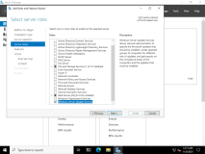

1. In the pop-up window, click **Add Features**.

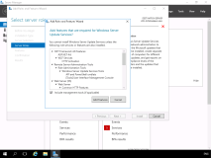

1. On the **Select server roles** page, click **Next**.
2. On the **Select features** page, click **Next**.

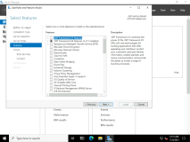

1. On the **Windows Server Update Services** page, click **Next**.

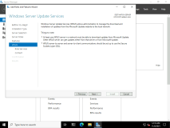

1. On the **Select role services** page, confirm that both **WID Connectivity** and **WSUS Services** are selected, and then click **Next**.

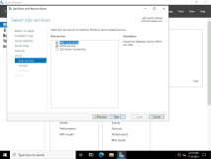

1. On the **Content location selection** page, in the text box, type [**C:\WSUSUpdates**](urn:gd:lg:a:send-vm-keys) and then click **Next**.

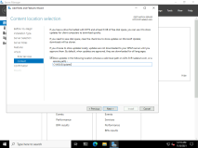

1. On the **Confirm installation selections** page, click **Install**.

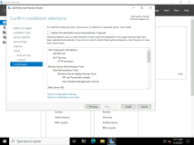

1. When the installation completes, click **Close**.

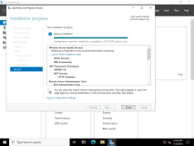

1. In Server Manager, click **Tools**, and then click **Windows Server Update Services**.

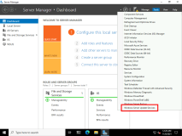

1. In the **Complete WSUS Installation** dialog box, click **Run**, and wait for the task to complete. Click **Close**.

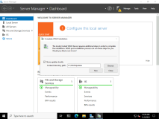

Do NOT close the **Windows Server Update Services Configuration Wizard:LON-SVR1** window.

Task 2: Configure WSUS to synchronize with an upstream WSUS server

1. In the **Windows Server Update Services Configuration Wizard:LON-SVR1** window, click **Next** twice.

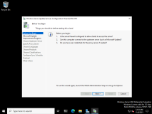

1. On the **Choose Upstream Server** page, click **Synchronize from another Windows Server Update Services server**, and in the **Server name** text box, type [**LON-SVR4.Adatum.com**](urn:gd:lg:a:send-vm-keys) and then click **Next**.

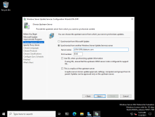

1. On the **Specify Proxy Server** page, click **Next**.

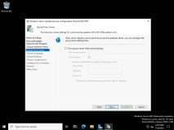

1. On the **Connect to Upstream Server** page, click **Start Connecting**. Wait for the upstream server settings to be applied, and then click **Next**.

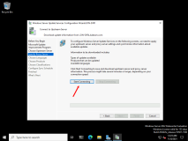

1. On the **Choose Languages** page, click **Next**.

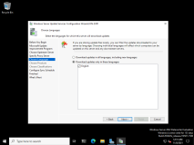

1. On the **Set Sync Schedule** page, click **Next**.

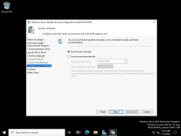

1. On the **Finished** page, select the **Begin initial synchronization** check box, and then click **Finish**.

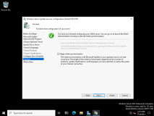

1. In the **Update Services** console, in the navigation pane, double-click **LON-SVR1**, and then click **Options**.

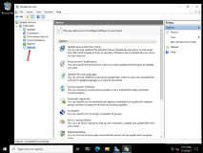

1. In the **Options** pane, click **Computers**.

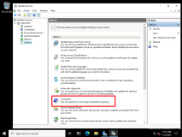

1. In the **Computers** dialog box, select **Use Group Policy or registry settings on computers**. Click **OK**.

**Note:** You might need to wait until synchronization is complete before you can click **OK**. Simply exit the Computers screen and try again after a few minutes.

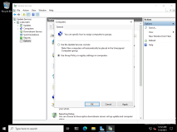

**Results** After completing this exercise, you should have implemented the Windows Server Update Services (WSUS) server role.

Exercise 2: Configuring update settings

**Scenario**

You need to configure the Group Policy settings to deploy automatic WSUS settings to client computers. With the WSUS role configured on LON-SVR1, you must ensure that the Research Department has its own computer group in WSUS on LON-SVR1. You must also configure client computers in the Research organizational unit (OU) to use LON-SVR1 as their source for updates.

The main tasks for this exercise are as follows:

1. Configure WSUS groups.
2. Configure Group Policy to deploy WSUS settings.
3. Verify the application of Group Policy settings.
4. Initialize Windows Update.

Task 1: Configure WSUS groups

1. On [**LON-SVR1**](urn:gd:lg:a:select-vm), in the **Update Services** console, in the navigation pane, double-click **Computers**.

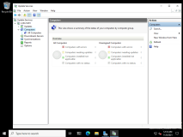

1. Click **All Computers**, and then in the **Actions** pane, click **Add Computer Group**.

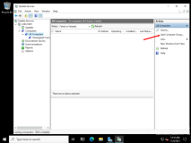

1. In the **Add Computer Group** dialog box, in the **Name** text box, type [**Research**](urn:gd:lg:a:send-vm-keys), and then click **Add**.

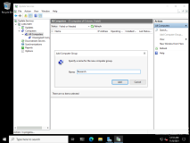

Task 2: Configure Group Policy to deploy WSUS settings

1. Switch to [**LON-DC1**](urn:gd:lg:a:select-vm) and send the [**CTRL+ALT+DEL**](urn:gd:lg:a:send-vm-key-combo) command and login as [**Adatum\AdatumAdmin**](urn:gd:lg:a:send-vm-keys) with the password [**Pa55w.rd**](urn:gd:lg:a:send-vm-keys)
2. Click **Start** and select **Server Manager**.

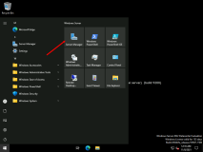

1. In Server Manager, click **Tools**, and then click **Group Policy Management**.

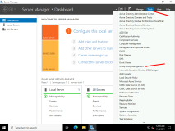

1. In the **Group Policy Management** console, double-click **Forest: Adatum.com**, double-click **Domains**, and then double-click **Adatum.com**.

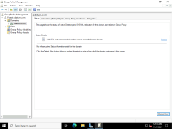

1. Right-click the **Research** organizational unit (OU), and then click **Create a GPO in this domain, and Link it here**.

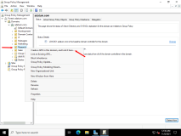

1. In the **New GPO** dialog box, in the **Name** text box, type [**WSUS Research**](urn:gd:lg:a:send-vm-keys) and then click **OK**.

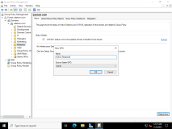

1. Double-click the **Research** OU, right-click **WSUS Research**, and then click **Edit**.

**Note:** If the **Group Policy Management Console** dialog box appears, click **OK** to continue.

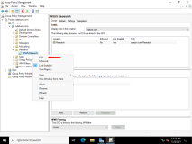

1. In the Group Policy Management Editor, under **Computer Configuration**, double-click **Policies**, double-click **Administrative Templates**, double-click **Windows Components**, and then click **Windows Update**.

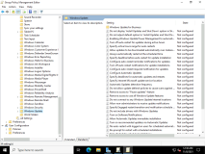

1. In the **Settings** pane, double-click **Configure Automatic Updates**, and then click the **Enabled** option.

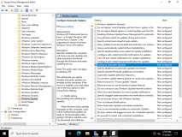

1. In the **Configure automatic updating** field, click and select **4 - Auto download and schedule the install**, and then click **OK**.

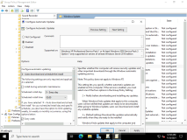

1. In the **Settings** pane, double-click **Specify intranet Microsoft update service location**, and then click the **Enabled** option.

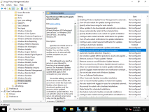

1. In the **Set the intranet update service for detecting updates** and the **Set the intranet statistics server** text boxes, type the following and then click **OK**.
2. http://LON-SVR1.Adatum.com:8530

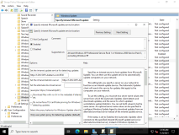

1. In the **Settings** pane, double-click **Enable client-side targeting**.

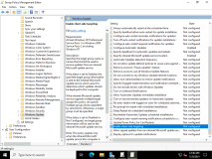

1. In the **Enable client-side targeting** dialog box, click the **Enabled** option, and in the **Target group name for this computer** text box, type [**Research**](urn:gd:lg:a:send-vm-keys), and then click **OK**.

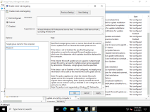

1. Close the Group Policy Management Editor and the **Group Policy Management** console.
2. In Server Manager, click **Tools**, and then click **Active Directory Users and Computers**.

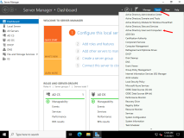

1. In Active Directory Users and Computers, double-click **Adatum.com**, click **Computers**, right-click **LON-CL1**, and then click **Move**.

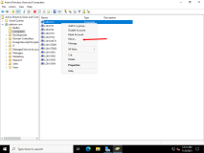

1. In the **Move** dialog box, click the **Research** OU, and then click **OK**.

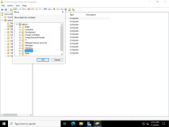

1. Close Active Directory Users and Computers.

Task 3: Verify the application of Group Policy settings

1. Switch to [**LON-CL1**](urn:gd:lg:a:select-vm) and send the [**CTRL+ALT+DEL**](urn:gd:lg:a:send-vm-key-combo) command and login as [**Adatum\AdatumAdmin**](urn:gd:lg:a:send-vm-keys) with the password [**Pa55w.rd**](urn:gd:lg:a:send-vm-keys)
2. Right click the start menu and select **Windows Terminal (Admin)**.

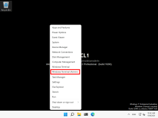

1. Run the following two commands to set the Windows Update service to automatic and to start the service.
2. Set-Service wuauserv -StartupType Automatic
3. Start-Service wuauserv
4. Select the Start Menu search box, type [**Updates**](urn:gd:lg:a:send-vm-keys), and then click **Windows Update settings**.

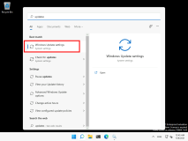

1. Click **Advanced options**, and ensure Windows updates are not paused. Close the **Update settings** window.

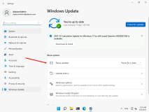

1. Click the **Start** button, click **Power**, and then click **Restart**.

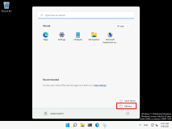

1. After [**LON-CL1**](urn:gd:lg:a:select-vm) restarts, send the [**CTRL+ALT+DEL**](urn:gd:lg:a:send-vm-key-combo) command and login as [**Adatum\AdatumAdmin**](urn:gd:lg:a:send-vm-keys) with the password [**Pa55w.rd**](urn:gd:lg:a:send-vm-keys).
2. Right-click the Start Menu and select **Windows Terminal (Admin)**.

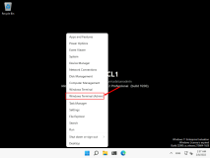

1. In the Terminal, enter the following command and then press **Enter**.
2. Gpresult /r

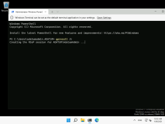

1. In the output of the command, under **Computer Settings**, confirm that **WSUS Research** is listed under **Applied Group Policy Objects**.

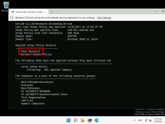

Task 4: Initialize Windows Update

1. On [**LON-CL1**](urn:gd:lg:a:select-vm), in the Windows Terminal, type the following command, and then press Enter:
2. Wuauclt.exe /detectnow /reportnow

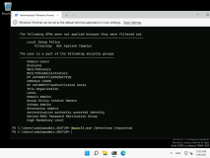

1. Switch to [**LON-SVR1**](urn:gd:lg:a:select-vm)
2. In the **Update Services** console, expand **Computers**, expand **All Computers**, and then click **Research**.

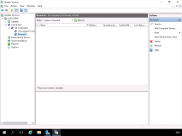

1. In the **Status** drop-down list, click **Any**, and then click **Refresh**.

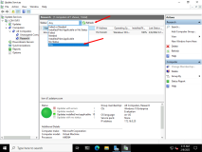

1. Verify that **LON-CL1** appears in the **Research** group. If it does not, then repeat steps 1 through 3, and then click **Refresh**. It might take several minutes for **LON-CL1** to display.

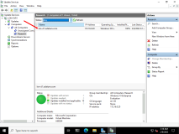

1. Verify that updates are reported as needed. If not, repeat steps 1-3. It might take 10 to 15 minutes for updates to register. Click **Refresh** every few minutes as you wait.

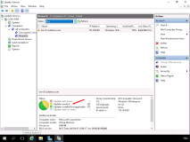

**Results**: After completing this exercise, you should have configured update settings for client computers.

Exercise 3: Approving and deploying an update by using WSUS

**Scenario**

After you have configured the Windows Update settings, you can view, approve, and then deploy required updates. You want to use LON-CL1 as a test case for the Research Department. You will approve, deploy, and verify an update on LON-CL1 to confirm the proper configuration of the WSUS environment.

The main tasks for this exercise are as follows:

1. Approve WSUS updates for the Research computer group.
2. Deploy updates to LON-CL1.
3. Verify update deployment to LON-CL1.
4. Prepare for the next lab.

Task 1: Approve WSUS updates for the Research computer group

1. On [**LON-SVR1**](urn:gd:lg:a:select-vm), in the **Update Services** console, under **Updates**, click **All Updates**.

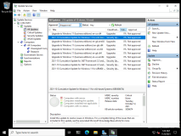

1. Scroll to the bottom of the list of updates, right-click **2021-10 Cumulative Update for Windows 11 for x64-based systems (KB5006674)**, and then click **Approve**.

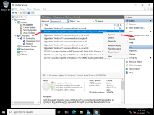

1. In the **Approve Updates** window, in the **Research** drop-down list box, select **Approved for Install**.

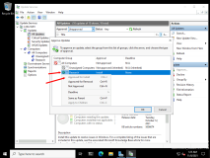

1. Click **OK**, and then click **Close**.

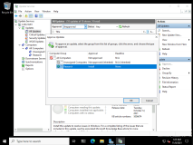

Task 2: Deploy updates to LON-CL1

1. Switch to [**LON-CL1**](urn:gd:lg:a:select-vm), in the terminal window, type the following command, and then press Enter:
2. Wuauclt.exe /detectnow

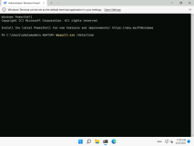

1. Click **Start** and search for [**Windows Update**](urn:gd:lg:a:send-vm-keys) and then select **Windows Update Settings**

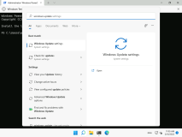

1. In the list if necessary, click **Check for updates**.

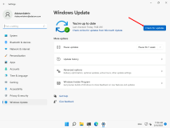

1. Select **Download & install**.

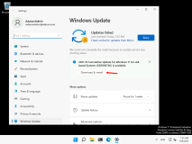

1. The update begins to download.

**Note:** The update installation can take a significant amount of time.

**Results**: After completing this exercise, you should have approved and deployed an update by using WSUS.

**Congratulations!** You have now completed this lab. To continue to the next lab click End Lab in the Tools Menu . If you wish to contiue with this lab at a later date ensure you save the lab environment rather than ending it.